

**Peppard Church of England Primary School**

**SCHOOL UNIFORM POLICY**

|  |  |  |
| --- | --- | --- |
| **Approved by:** | Headteacher | **Date:** June 2000 |
| **Last reviewed on:** | January 2024 | |
| **Next review due by:** |  | |

School Uniform.

* Red sweatshirt, or cardigan with logo (purchased from Mapac)
* White polo shirt
* Plain grey pinafore dress, skirt or tailored trousers, or shorts with grey tights, or grey or white socks
* Red checked summer dress/playsuit with white socks
* Smart black practical footwear (see appendix 1)

Long hair must be tied back and hair decoration should be small and in the school colours.

For sport;

* Red sweatshirt with logo (purchased from Mapac)
* Red school t-shirts with logo (purchased from Mapac)
* Navy sports shorts/skort, plain navy jogging bottoms, plain navy leggings
* Trainers
* Optional Red school cap (purchased from Mapac)

For swimming;

Swimming: costume, swimming hat and towel.

Coats.

It is essential that all children have a coat that is appropriate for the weather but is also easy to move and play in. Coats and hats are also available from Mapac.

Sporting days.

Children are asked to come to school in PE kit, if they have PE, or a sports club at school.

Labelling.

Please label all your child’s clothing and belongings with your child’s name.

Any parent requiring assistance to purchase school uniform should approach the Headteacher or Chair of Governors. Any such requests will be treated confidentially.

Appendix 1.

Smart, black footwear.

This could be any traditional black shoes bought from the usual retailers, such as Clarks, Next, etc.

The three images below, show shoes that could also be used as both school shoes and trainers. The shoes must be all black and have no other colour markings on them. Some manufacturers use the term, ‘triple black.’

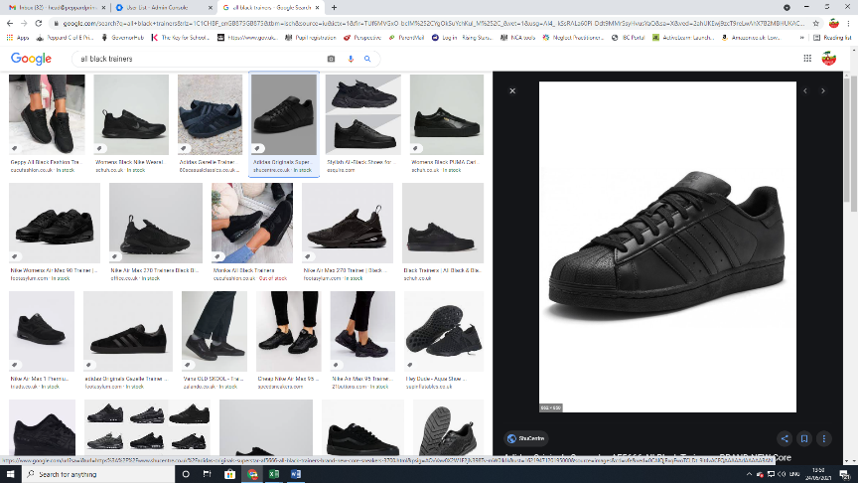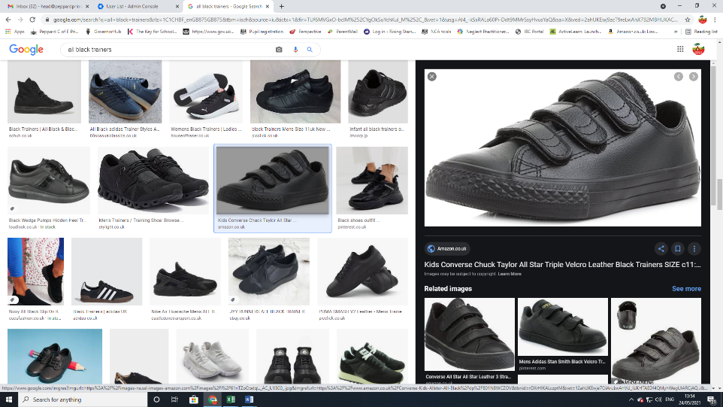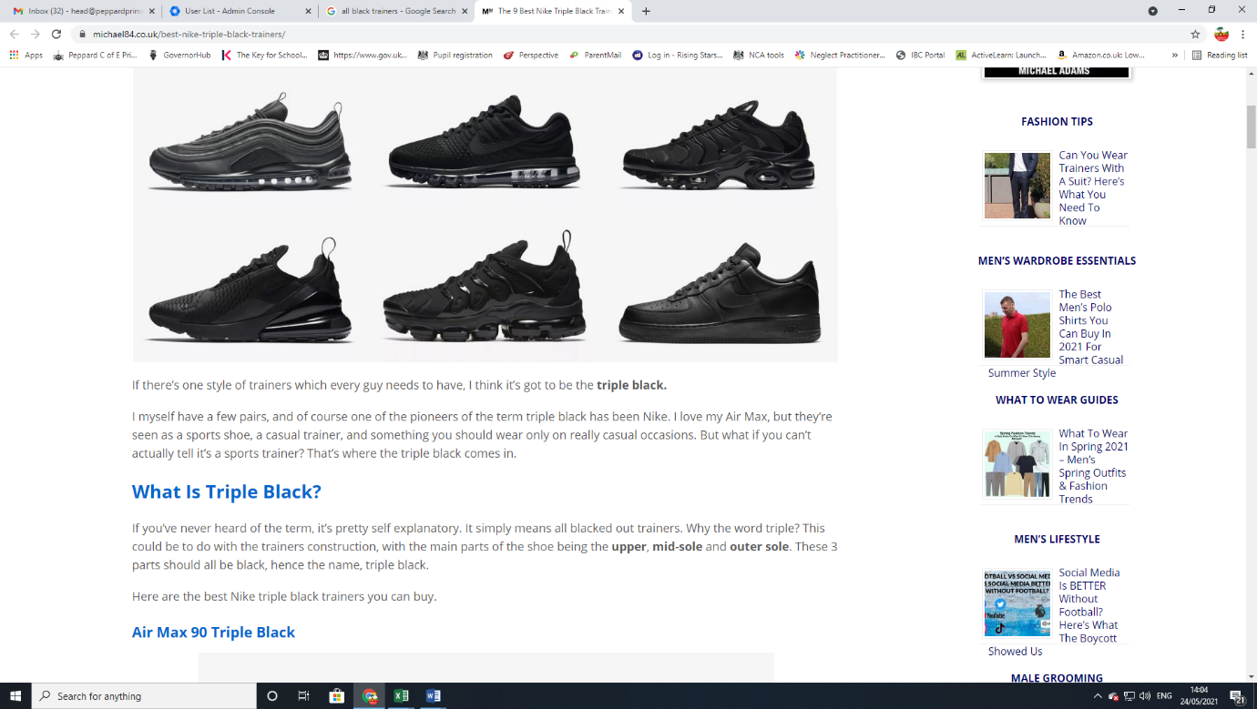

Personal Items.

Accessories

Nail polish, make-up and tattoos are not permitted.

Watches and stud earrings may be worn. All jewellery must be removed for PE in order to comply with Health and Safety regulations. If a child cannot remove their studs unassisted they should not wear them on PE days.

Children should bring a pair of named Wellingtons, or trainers, which can be left at school for outdoor play.

Lost Property

We have a lost property box which is kept outside the office. Please feel free to check the box at any time for any lost belongings.

Unnamed lost property will be removed from the box at the end of each term and may be included in the second hand uniform sales.

Toys

We ask that children do not bring any personal belongings or toys to school, as these can get lost or broken. If they have something relevant to their learning in class, however, we would be delighted for them to bring it to show to their class.